ASSIGNMENT 1

OBJECTIVE:

Make a Smart Home in Tinkercad, using 2+ sensors, Led, Buzzer in single code and circuit.

CODE:

// C++ code

//

int trig=13;

int echo=12;

void setup()

{

pinMode(trig,OUTPUT);

pinMode(echo,INPUT);

pinMode(11,INPUT);

Serial.begin(9600);

pinMode(10,OUTPUT); // buzzer for temp

pinMode(8,OUTPUT); //led of ultrasonic

pinMode(9,OUTPUT); //led of pir

}

void loop()

{

double a=analogRead(A5);

Serial.print("adc value:");

Serial.println(a);

double v=a/1024;

double tvolt=v\*5; // here 5 is in volt and thhiseqe for elect to temp volt

Serial.print("temp volt:");

Serial.println(tvolt);

double o=tvolt-0.5; //for octol and 0.5 for min volt for octal

double t=o\*100;// this two eqe for volt to temp

Serial.print("temp is:");

Serial.println(t);

//delay(2000);

digitalWrite(trig,LOW); //off

digitalWrite(trig,HIGH);

delayMicroseconds(10);

digitalWrite(trig,LOW); // till this for trigger

float dur=pulseIn(echo,HIGH); // echo on

float dist=(dur\*0.0343)/4; //cm to m

Serial.println("distance:");

Serial.println(dist); //ultra sonic

int m=digitalRead(11);

Serial.print("motion detected : ");

Serial.println(m);

if(t>=40)

{

Serial.println("\*\*\*\*\*\*\*\*house on fire\*\*\*\*\*");

digitalWrite(10,HIGH);//to get

}

else

{

digitalWrite(10,LOW);

}

//delay(2000);

if(dist<=18)

{

Serial.println("\*\*please kindly turn on light and fan\*\*");

digitalWrite(8,HIGH); //

}

else

{

Serial.println("\*\*\*\*\*turn off light and fan\*\*\*\*");

digitalWrite(2,LOW);

}

if(m==1)

{

Serial.println("\*\*\*\*\*\*\*open the cupboard\*\*\*\*\*\*");

digitalWrite(9,HIGH);

delay(50);

}

else

{

Serial.println("\*\*\*\*\*\*\*\*close the cupboard\*\*\*\*\*");

digitalWrite(9,LOW);

}

delay(50);

}

OUTPUT:

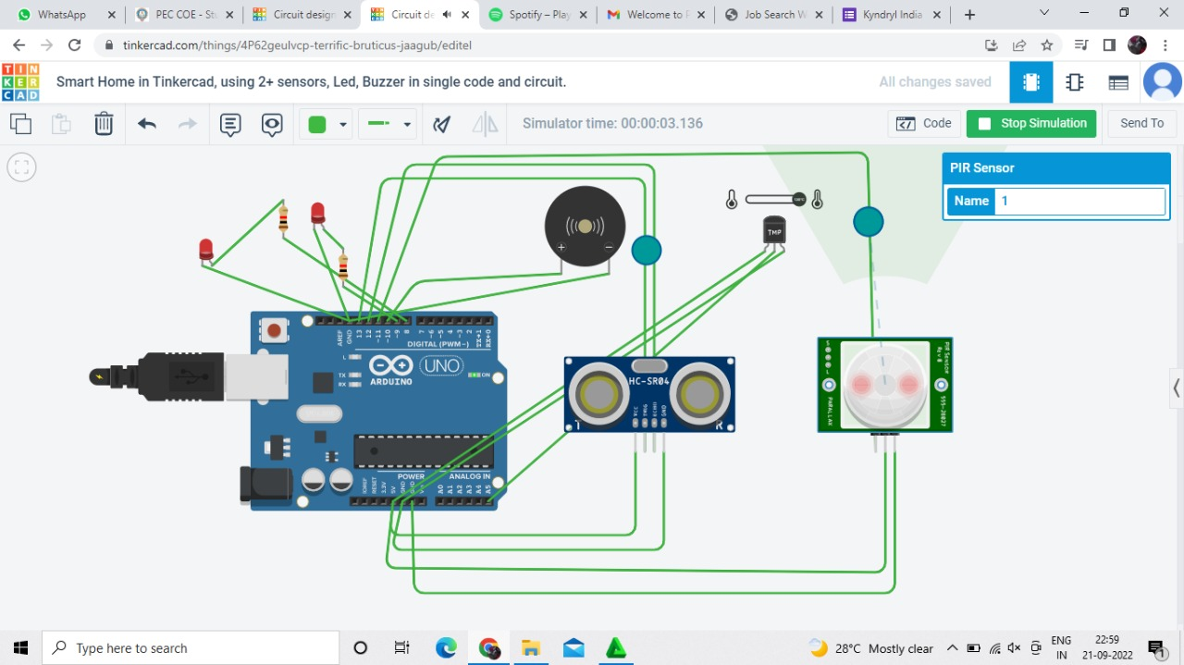

STIMULATION LINK:

https://www.tinkercad.com/things/4P62geulvcp-terrific-bruticus-jaagub/editel